**Unit-Type Purchase Orders:** This topic will walk you through how to create, manage, and ultimately close out Unit-Type Purchase Orders (POs). You should choose this PO type whenever you use Integrated Purchase Orders (IPO) to order new equipment units, as the program includes process of adding new unit records to the system and the specific accounting involved in the steps required to complete the PO.

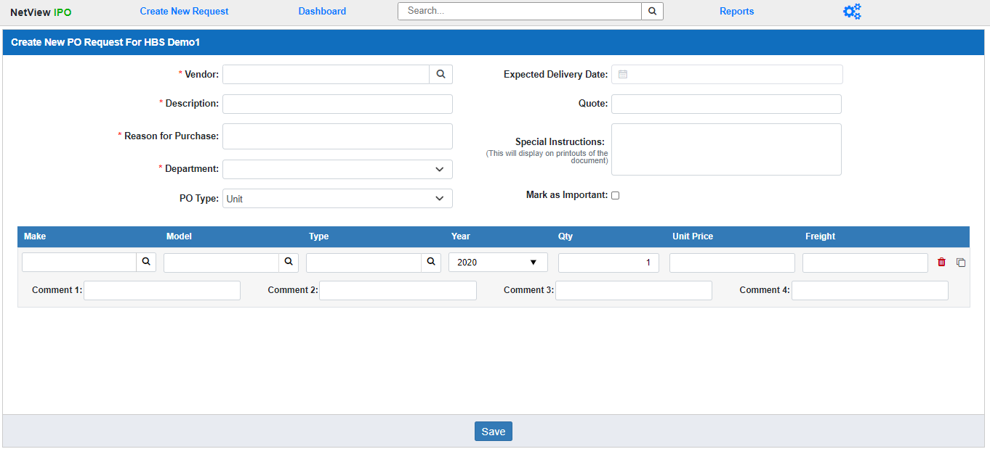

**Create New Unit PO Request:** To begin, a user with a **Buyer** role must create the new Unit purchase request in IPO**.** Click on **Create New Request** in the IPO Program Header. The screen above will open. Fill in the required information to create your request.

Vendor: Enter the full vendor number for the request, or use the Vendor Lookup to find the vendor if you don’t know the full number, or only know the vendor’s name. This is a **required** field, and the vendor must **already exist** in the system (if you need to add them in Vendor Maintenance (VIM), do it **before** creating the request).

Description: Enter a description for the request. This will serve as an additional identifier for the order when you look for it on the Dashboard or the IPO Document Search. This is a **required** field.

Reason for Purchase: Enter the reason you want to make this purchase. This is a **required** field.

Department: Use the drop-down menu to select which department you are making the request for. This is a **required** field. The options will consist of the 7 standard departments—Administration, Inventory, Rental, Sales, Service, Transport, and Wholegoods—as well as any **custom** departments your dealership has added to the system.

PO Type: Select **Unit** as the PO Type. This will set the **Add Line Grid** below to record Unit Type line items (see below for details).

Expected Delivery Date: If you have an idea what the order’s expected delivery date might be, you can enter it in this **optional** field or select it from the calendar.

Quote: If you have a quote number to go with your request, enter it in this **optional** field.

Special Instructions: You can use this **optional** field to add a special delivery note to the request, if desired. These instructions will then display on printouts of the document.

Mark as Important: If you want to mark the request as “Important,” essentially flagging it as a priority item for other roles that will work on it, check this box. This will mark the document’s entry in the columns on the **Column Dashboard View** with an “Important” indicator (a red circle with an exclamation mark inside).

Add Line Grid: Having selected **Unit** as the PO Type, the Add Line Grid at the bottom of the screen will be formatted specifically to add Unit-Type line items to the purchase request. Fill in the fields to create the line. Once you go through the first line, a new line will appear automatically. Add as many line items as needed for your request.

**Make:** Enter the unit make for the line item here, or use the Make Search to look one up. The system will **validate** anything you type in to make sure it actually exists as a make in the system. You can add the make to the system if it does not exist, but **only** if you have **Unit Maintenance (UM)** permissions.

**Model:** Enter the unit model for the line item here, or use the Model Search to look one up. The system will **validate** anything you type in to make sure it actually exists as a make in the system. You can add the make to the system if it does not exist, but **only** if you have **Unit Maintenance (UM)** permissions.

**Type:** Enter the unit type for the line item here, or use the Type Search to look one up. The system will **validate** anything you type in to make sure it actually exists as a make in the system. You can add the make to the system if it does not exist, but **only** if you have **Unit Maintenance (UM)** permissions.

**Year:** Enter the unit year or select it from the drop-down menu.

**Qty:** Enter the quantity of this make/model/type of unit you wish to order. This field will always default to **1.**

**Unit Price:** Enter the unit price, or price per piece of equipment, in this field. **DO NOT** enter the total price of all units on the line, or you will have significant issues handling the order’s accounting later.

**Freight:** If you know the Freight amount for the line at this time, enter it here. You will be able to add the freight to the document later if you do not know it at the moment. **NOTE:** Do not leave this field **blank**, as it will cause an error. If there is **no** Freight on this line, just enter “**0.00.**”

**Comment 1-4:** Use these four fields to enter any comments about the unit(s) being ordered on this line. These will eventually be recorded in their unit record(s).

**Delete:** If you want to remove a line after filling it out, or if you have accidentally generated an unneeded line, click the icon of a red trash can at the far right end of the line. This will delete the line.

**Clone:** If at any point you want to completely duplicate a line item, click the  icon on the far right end of the line. This will generate a duplicate of the line directly below it in the grid, which you can modify if needed.

Save: Once you have filled in the required fields and added the line items you want to include, click this button to generate your request as a **Requisition** document.

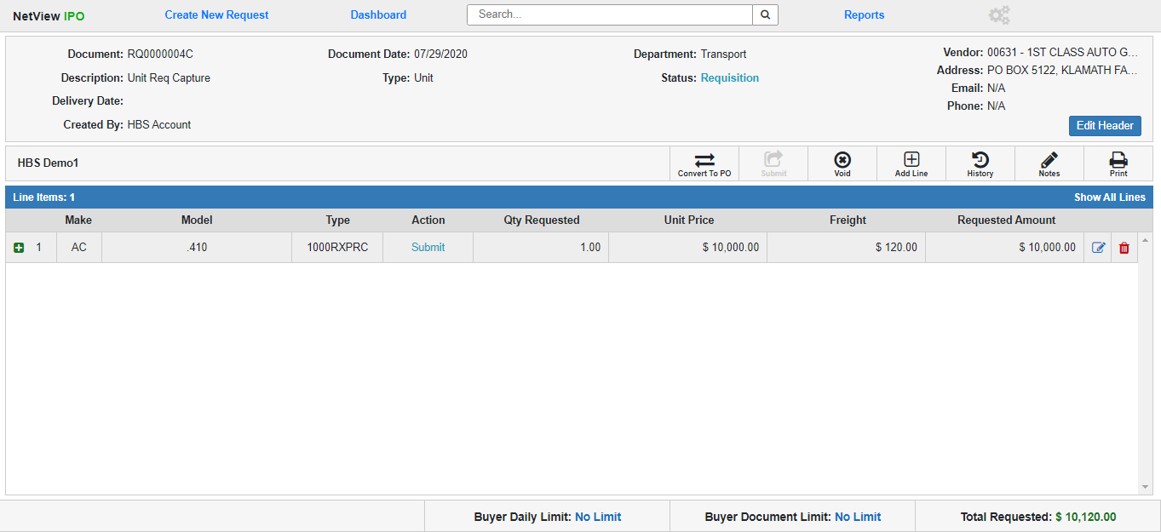

**Open Unit Requisition:** The Open Requisition document screen allows users to edit the Requisition before converting it into a Purchase Order (at which point most of the document will be locked for editing). A user can **only** make modifications to an open Requisition if they are a **Buyer** for the Requisition’s assigned department at the location where the Requisition was created.

Requisition Header: The Header section provides basic information about the entire document. Click the **Edit Header** button to edit the Header fields. As you can see from the image below, only the fields you can actually edit will change when you click the button.



**Document:** This field shows the document number. It **cannot** be changed.

**Description:** This field shows the document description, which can be changed.

**Delivery Date:** This field can hold an expected delivery date for the purchase. If you obtain this information while the document is still a Requisition, you can add it here by entering it or using the calendar to select the date. You can also edit it at any time if the date changes before you convert the Requisition into a Purchase Order.

**Created By:** This field shows the user ID of the Buyer who originally created the Requisition. If you made the Requisition, your user ID will appear here. This field **cannot** be changed.

**Document Date:** This field shows the Requisition’s creation date. It **cannot** be changed.

**Type:** This field shows that the Requisition is a Unit-Type document. You **cannot** change the PO Type once you have set it during creation.

**Department:** This field shows the Requisition’s assigned document. Use the drop-down menu to change the document’s department. **NOTE:** You will **only** be able to select a department that **your IPO role has permissions for**.

**Status:** This field shows the document’s current status, which in this case will be **Requisition**.

**Vendor:** This part of the header will show you information about the document’s vendor, taken directly from the vendor record in VIM. As a result, if any of these fields indicate the information is not available, that is because it is not present in the vendor record. The fields show:

* Vendor Number and Name
* Vendor Address
* Vendor Email
* Vendor Phone Number

You can change the document’s vendor while it is still a Requisition, which will then automatically update the remaining information from the new vendor’s record.

**Save:** Click this button after modifying the header fields to save the new information and return the header to its display-only state.

**Cancel:** Click this button to return the header to its display-only state **without** saving any changes you may have made to the fields.

Unit Requisition Line Items: The grid below the header contains all the line items you added to the Requisition during creation, constructed as a main line and a subline with more information that you can view by **expanding** the line. If you want to expand all the lines at once, use the **Show All Lines** feature in the upper-right corner of the grid. The feature will change to **Hide All Lines** after you click it; click that to hide all the expanded lines again.

**Main Unit Requisition Line Item:** The main line items on Unit Type Requisitions show the following information:

* **Line Number:** Each line item has an assigned, **unchanging** number for record-keeping purposes. That number will appear here, and will be assigned in order of the line’s creation (first line created is 1, etc.).
* **Make:** This field shows the item’s unit make.
* **Model:** This field shows the item’s unit model.
* **Type:** This field shows the item’s unit type.
* **Action:** This field shows the next action that need to be done to the line. On an **Open** **Requisition**, this action will always be **Submit**, indicating that a **Buyer** needs to submit, or convert, the Requisition into a Purchase Order.
* **Qty Requested:** This field shows the quantity of the item requested by the Buyer.
* **Unit Price:** This field shows the item’s unit price.
* **Freight:** This field shows the item’s freight amount, if recorded.
* **Requested Amount:** This field shows the total amount requested for the line item, which is calculated by multiplying the Unit Price by the Qty Requested and then adding Freight to the result.
* **Delete:** If for any reason you need to remove a line item from a Requisition before making the document into a Purchase Order, click the red trash can icon on the far right of the line item. The following warning will appear:

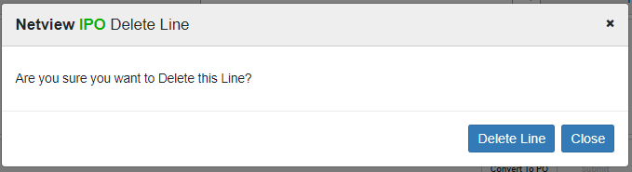

Click **Delete Line** to delete the line from the Requisition.

**Edit Unit Line Item:** If you need to edit a line item on a Requisition, click the  icon on the far right of the line. The following screen will open:

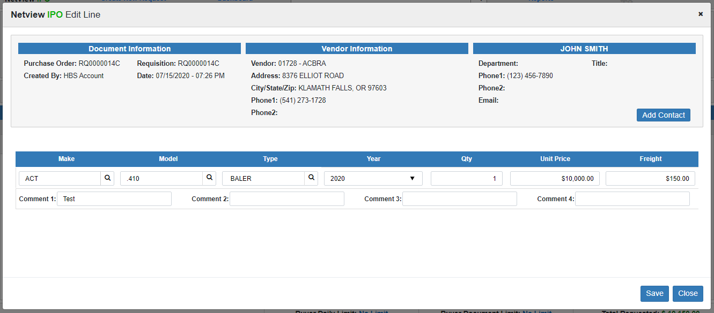

Make the edits you need, then click **Save**. The screen will close and the line item will be updated with the changes.

**\*\*FEATURE NOTE**:** The Header section you see in the image above is a common feature that will appear in several screens related to working on Requisition or PO documents. It offers you a quick snapshot of the basic document information in the same way as the main Document Header, though it also allows you to add or edit the Vendor Contact associated with the document by sending you to the vendor’s page in **Vendor Maintenance (VIM)**. If the vendor has a set contact, clicking **Add Contact** will send you to VIM and let you edit or change the contact. If the vendor does not, there will be a different link to VIM anyway allowing you to add one.

**Expanded Unit Line Item:** An **expanded** Unit line item on a Requisition will look like this:

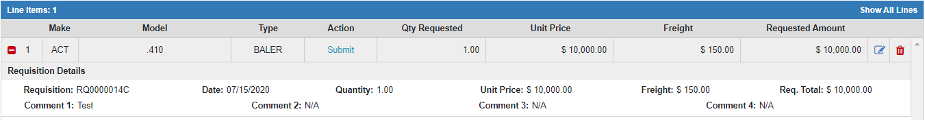

The **Requisition Details** holds line item’s Requisition information so that it will be preserved once the document becomes a Purchase Order.

* **Requisition:** This field shows the Requisition number.
* **Date:** This field shows the line item’s creation date. If the line was created during the initial document creation, this date will be the same as the Document Date.
* **Quantity:** This field shows the line item quantity.
* **Unit Price:** This field shows the line item’s unit price.
* **Freight:** This field shows the line item’s freight amount, if any.
* **Req. Total:** This field shows the total amount requested for the line item ((Unit Price x Quantity) + Freight).
* **Comment 1-4:** These fields hold any comments you added to the line item while creating it.



Unit Requisition Footer: The Requisition footer (pictured above) shows how much money the Buyer has left to request before they hit their Daily and Document Limits, as well as the current Total Requested Amount for the Requisition, which updates whenever the total value of the document changes. This keeps the Buyer aware of their spending limits and if the current request would go over those amounts, forcing them to submit it to an Approver.



Unit Requisition Document Actions: The **Document Actions Toolbar** displays below the Document Header and above the Line Items Grid. These buttons represent actions that a **Buyer** can perform on the document.

**Print:** Click this button to print a copy of the Requisition. The following window will open:

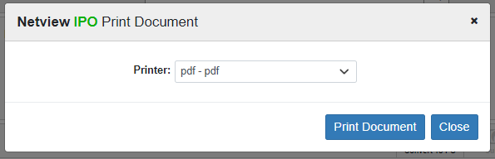

Select the printer to receive the document and click **Print Document**. Below is a sample Requisition printout:

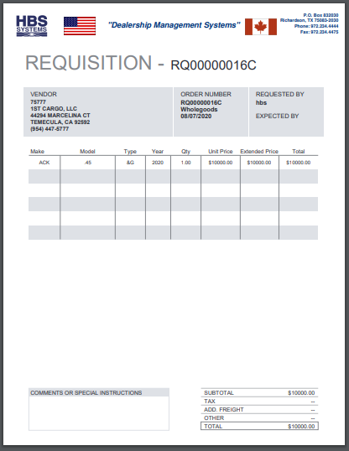

**Notes:** Click this button to view all notes attached to the document, along with what user created them and when.

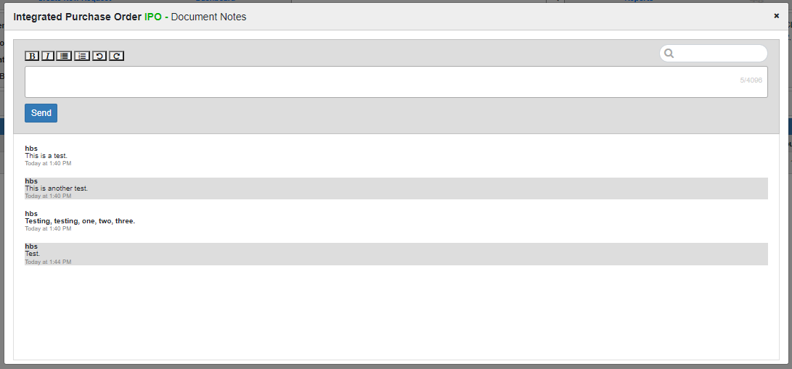

You can use the **Search** field at the top of the screen to filter the notes based on what you enter. Certain notes will also have **tags** indicating they were added to the document at specific points. For example, the note added in the **Special Delivery Note** field of the **Create New Request** screen will have a tag identifying it.

You can also **add** notes in this screen by entering the new note in the **Add Note** field below the Search and clicking **Send**. The screen also comes with standard text editing features so you can modify the note as desired (bold, underline, bullets, numbering, etc.).

**History:** Click this button to view the document’s history, which records all actions which have been performed on the document:

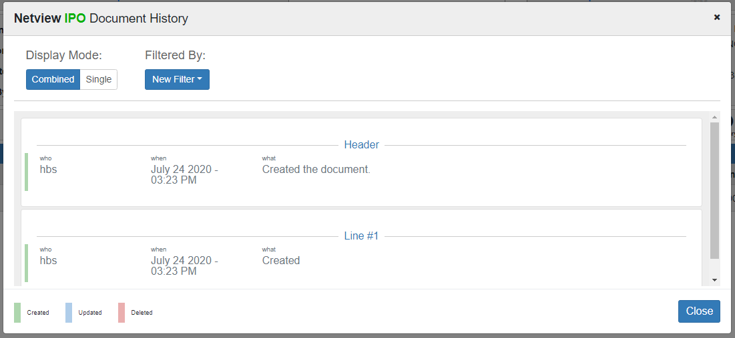

The program classifies each action based on what part of the document it was performed upon: the Header or a Line Item (identified by their Line Number). Each action is also **color-coded** as one of three action categories, as explained by the legend in the bottom left-hand corner of the screen:

* **Created** (green): represents the initial document creation
* **Updated** (blue): represents any changes to a document element
* **Deleted** (red): represents anything being removed from the document

There are two ways to display the document history. The first is the **Combined** display, pictured above, which groups all actions performed on a single document item together: all actions performed on the Header are listed together, all actions on Line #1 are together, etc.

You can use the **Filtered By** field if you want to only look at a specific grouping of document actions: select a document element from the dropdown (Header, Line #1, etc.), and the screen will automatically close all the sections except the one for that element:

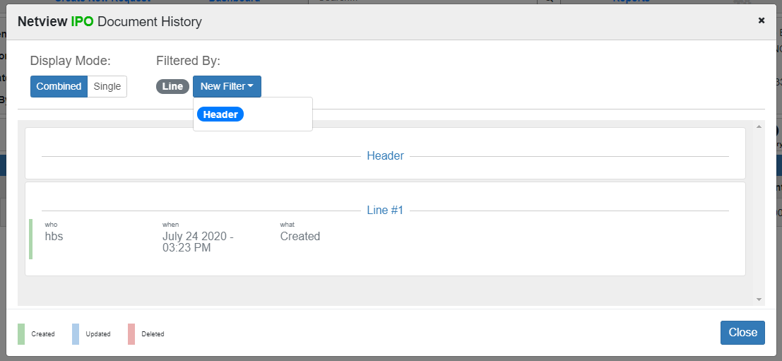

Click the filtered element again to clear it and reopen the other sections.

The other mode is the **Single** display, which displays all the actions in a single list:

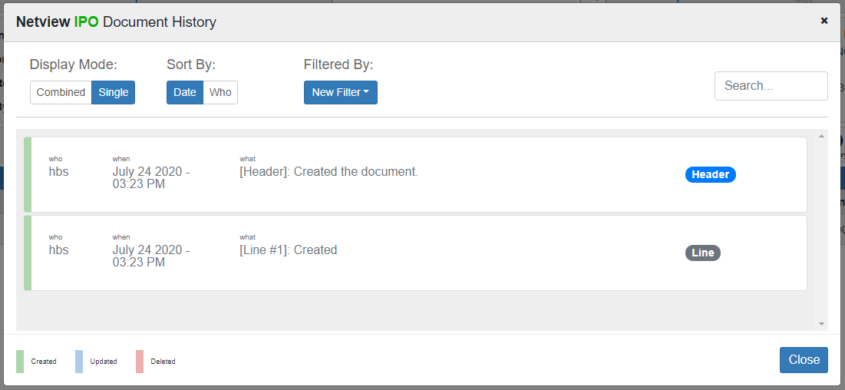

The list can be sorted by **date** (shows most recent action first) or by **user** (lists the actions alphabetically by their user, essentially grouping the actions together). The **Filtered By** feature is still available in this mode to help you look for specific actions, but the mode also provides a **Search** field to help you narrow the list down further.

**Add Line:** If you want to add a new line to the Requisition before converting it to a Purchase Order, click this button. The following screen will open:

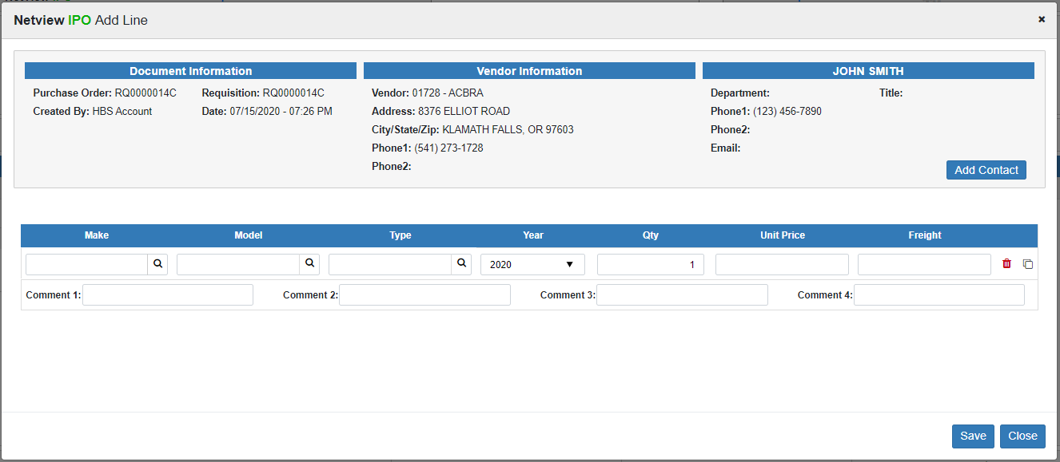

Fill in the line items the same way you did when originally creating the Requisition. You can create as many new lines here as needed. When you are done, click **Save** to add the new lines to the Requisition.

**Void:** If at any time you want to **delete** the **entire** Requisition, click this button. The following screen will appear:

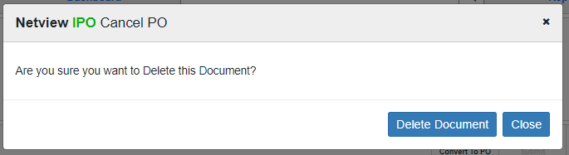

Click **Delete Document** to delete the Requisition. You will be returned to your default Dashboard, where the Requisition will no longer be present among the other active documents.



**Converting/Submitting a Requisition:** The final two Document Actions represent the next step in the PO process: changing the Requisition into an actual Purchase Order. How a Buyer does this depends on **whether or not the document’s Total Requested Amount goes over one or both of their set limits**, as that determines whether or not a user with an **Approver** role needs to look at the document.

Convert to PO: If the Total Requested Amount **does not exceed** the Buyer’s Daily and/or Document Limits, then this button will be active. Click on it to directly convert the Requisition into a Purchase Order. The following window will appear:

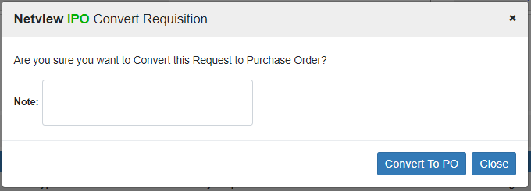

Add any notes you would like, then click **Convert To PO**. The document will automatically change into a Purchase Order:

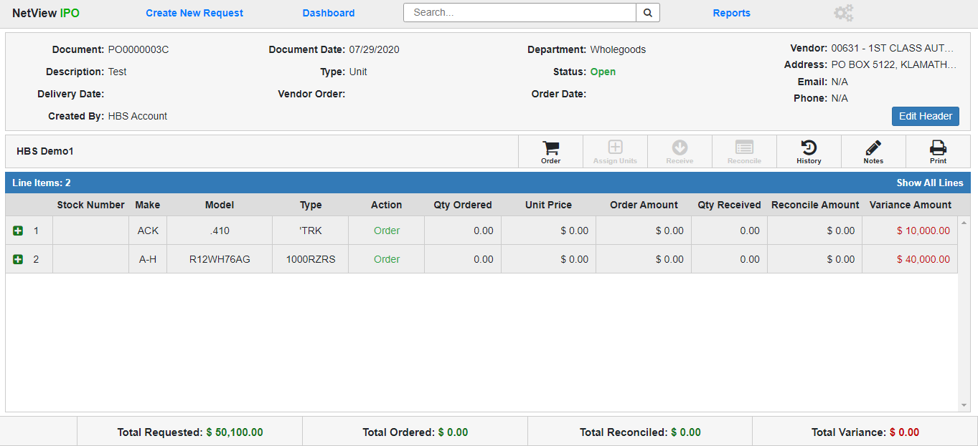

It will also now appear in the **Open PO** column on the Column Dashboard View, and have both a new PO document number and a status of **Open** on the List View.

At this point, the **Buyer** can **no longer act** on the document; their role in creating the Purchase Order is done.

Submit: If the Total Requested Amount **exceeds** the Buyer’s Daily and/or Document Limits, then this button will be active, indicating that the Requisition requires **approval** before it can become a Purchase Order. Click the button to submit the Requisition for approval. The following window will open:

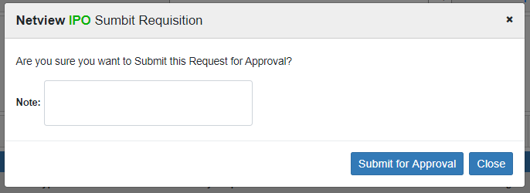

Add any notes you want and click **Submit for Approval**. This will convert the document directly into a **Pending Approval Requisition** (see image below) and send a notification via the **Messaging** feature to any **Approvers** with appropriate **Approval Limits** within the document’s location and department that they need to review the document. The system will also create a **task** in the users’ **Tasks ActiveTile** that will allow them to open the document directly from the tile on their Desktop.

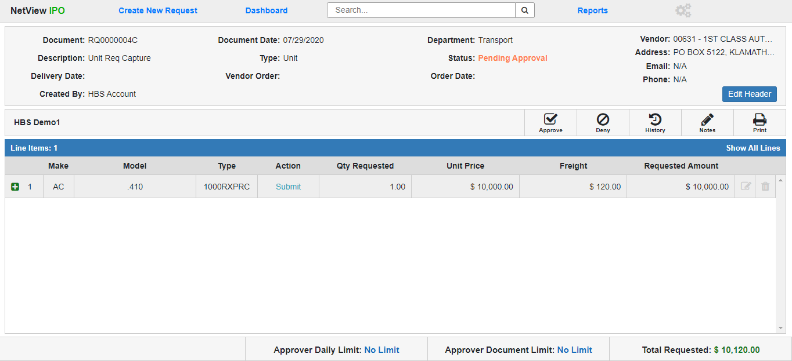

**Unit Type Pending Approval Requisition:** A Unit Type Requisition with a **Pending Approval** status has only a few, if significant, differences from an Open Requisition, which this section will highlight. Only users with an **Approver** role can act on a Pending Approval Requisition, and then only if that document’s Total Requested Amount is within theirApproval Limits.

Pending Approval Header Changes: What fields appear in the Requisition Header and which ones can still be edited using the Edit Header feature will change when the document’s status becomes Pending Approval.



**Document:** The document number will not have changed and will still be **display only**.

**Description:** The document description will still be **editable** at this point.

**Delivery Date:** The delivery date will still be **editable** at this point.

**Created By:** The user created by will still be **display only**.

**Document Date:** The document date will still be **display only**.

**Type:** The document type will still be **Unit** and **display only**.

**Vendor Order:** This is a **new, editable** field added when the Requisition’s status becomes Pending Approval. It can hold the vendor-assigned order number for the purchase, which you will eventually be **required** to provide for a **Unit PO**. If the number is known at this time, the Approver may enter it.

**Department:** The Approver can still **edit** the document’s department, but as with the Buyer, they can only change it to a department that they have permissions for as part of their role.

**Status:** The status will have changed to “Pending Approval” and still be **display only**.

**Order Date:** This is a **new, editable** field added when the Requisition’s status becomes Pending Approval. It can hold the date that you placed the actual order with the vendor, which you will eventually be **required** to provide for a **Unit PO**. If the Approver knows the date at this time, they may enter it.

**Vendor:** The Approver will **not** be able to edit the vendor; this field will be **disabled** for editing.

Pending Approval Line Items: The line items’ displayed information will not change once the Requisition’s status is Pending Approval, on the main line or in the hidden Requisition Details section. However, once the Requisition is Pending Approval, the line items can **no longer be changed or removed from the document**—the Edit Line and Delete Line functions will be **disabled**.



Pending Approval Footer Changes: The document footer will still show the Requisition’s Total Requested Amount, but will instead show the **Approver’s** Daily and Document Limits. As with the Buyer, this keeps the Approver mindful of how many requests they can still approve before they hit their limits and, at least in the case of the Daily Limit, must wait until the next day to resume their role.



Pending Approval Document Actions: While the **Notes, Print,** and **History** actions will remain available, the other Document Actions will be replaced with the key actions that an Approver can take on a Pending Approval Requisition: **Approve** and **Deny**. After looking over the document, the Approver must decide whether or not to convert the Requisition into a Purchase Order, and their decision will determine which Document Action they need to use.

**Deny a Requisition:** If you as the Approver decide to **deny the purchase request**, click the **Deny** button. The following window will open:

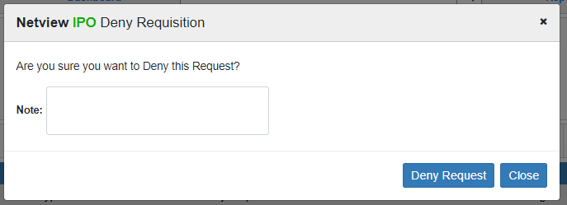

You can add an optional note explaining why you denied the request. Click **Deny Request** to finish the action. The Requisition will revert back to **Open** status, leaving it up to the Buyer to void the document if there is no chance the request will get approved.

**Approve a Requisition:** If you as the Approver decide to **approve** the Requisition to become a Purchase Order, click the **Approve** button. The following window will open:

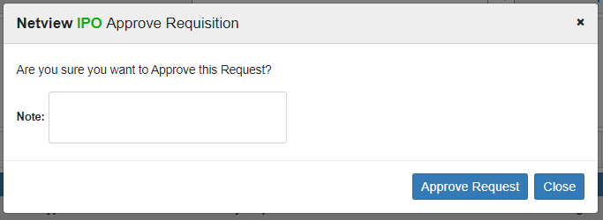

You can add an optional note to the action if desired. Click **Approve Request** to finish the action. The Requisition will automatically convert to a Purchase Order:



**Unit Type Purchase Order:** The Unit Type PO document largely **cannot** be edited, as by this point the details of the purchase have been approved and finalized. It will, however, be updated with new information as users with the appropriate roles act on the document. Only users with **Ordering Clerk, Receiving Clerk,** and/or **A/P Clerk** roles can act on an Open Purchase Order.

Unit PO Document Header: The document header for a Unit-Type Purchase Order is largely the same as on a Pending Approval Requisition, with some exceptions, including what can be edited with the **Edit Header** button.

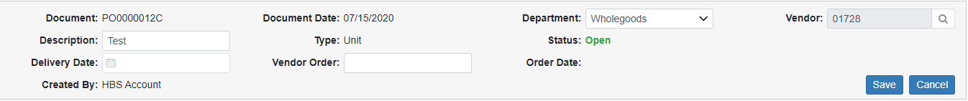

**Document:** The document now has a PO number instead of a Requisition number. The field is still **display only**.

**Description:** The document’s description can **still be edited** on a PO.

**Delivery Date:** The order’s delivery can **still be edited** on a PO.

**Created By:** This field is still **display only**.

**Document Date:** This field is still **display only**, and still shows the original date the request was created.

**Type:** This field still shows **Unit** and is still **display only**.

**Vendor Order:** This field holds the Vendor Order Number for the PO, which because this is a Unit PO will eventually be required as part of the **Order** step. The field can **still be edited** on this screen, even after the number is entered during the Order step.

**Department:** Users with the proper roles can still **edit** the document’s department, but as with the Buyer and Approver, they can only change it to a department that **they have permissions** for as part of their role.

**Status:** The document’s status now reads **Open**, indicating it is an Open Purchase Order, and is still **display only.**

**Order Date:** This field holds the PO’s Order Date, which because this is a Unit PO will eventually be required as part of the **Order** step. This field is **display only,** and will fill with the date entered by the **Ordering Clerk** when they conduct the Order step.

**Vendor:** The Vendor information **cannot** **be changed** once the document becomes a Purchase Order, and so is **display only**.

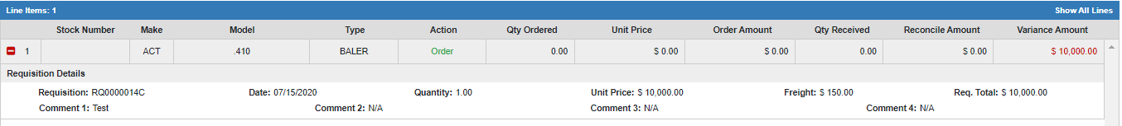

Unit Purchase Order Line Items: The main and expanded line items on a Unit Type PO are **no longer editable** by **any** user. However, the program will automatically update them with new information as users perform the **Order, Receipt,** and **Reconcile** steps on the document (done by the **Ordering Clerk**, **Receiving Clerk**, and **A/P Clerk** roles, respectively).

**Main Unit PO Line Item:**

* **Line Number:** The line item retains its line number from the original Requisition.
* **Stock Number:** This field holds the stock number(s) for the line item’s unit(s) once it is assigned, which cannot be done until after the **Order** step is completed.
* **Make:** This field holds the line item’s unit make.
* **Model:** This field holds the line item’s unit model.
* **Type:** This field holds the line item’s unit type.
* **Action:** This field shows the **next action** that needs to be performed on the line item. In the image above, it reads **Order**, meaning that the line has not yet been marked as actually ordered by an **Ordering Clerk**. This field will change to reflect the next action needed as users work on the PO.
* **Qty Ordered:** Once the **Order** step is performed on the line item, this field will fill with the quantity of the line item actually placed on order.
* **Unit Price:** Once the **Order** step is performed on the line item, this field will fill with the actual unit price of the line item listed on the order.
* **Order Amount:** Once the **Order** step is performed on the line item, this field will fill with the total amount of the line item actually placed on order ((Ordered Unit Price x Qty Ordered) + Freight).
* **Qty Received:** Once the **Receive** step is performed on the line item, this field will fill with the quantity of the item physically received by the dealership, per the **Receiving Clerk**.
* **Reconcile Amount:** Once the **Reconcile** step is performed on the line item, this field will fill with the total amount of the line item taken from the order’s invoice by the **A/P Clerk**.
* **Variance Amount:** This field will show the line’s variance amount, which will be the difference between the **Reconcile Amount** and the **Order Amount**. This will show if there was any discrepancy between what was originally stated as the line item’s cost and what was actually paid for the line item. While it will initially show the full value of the line, it will **recalculate** as the line is **reconciled**, showing the final Variance Amount once the line is completely reconciled**.** If there is **no** discrepancy, and the two amounts are the same, this field will show a **zero** which will be colored **blue**. Otherwise, the difference will appear as a **red** number, as in the image above. **NOTE:** This number will **not** include the **Freight** amount, but Freight will still be included in the **Reconcile** step and calculated for the **entire** document.

**Expanded Unit PO Line Item (Pre-Order):** Before any actions are performed on the PO, the expanded line items will only show the **Requisition Details** section that appeared on the Requisition. More sections will be added to the expanded line as users perform actions on the PO, which will be covered later in the topic.

* **Requisition:** This field shows the Requisition number of the original request document.
* **Date:** This field shows the line item’s creation date. If the line was created during the initial document creation, this date will be the same as the Document Date.
* **Quantity:** This field shows the line item’s **original requested** quantity.
* **Unit Price:** This field shows the line item’s **original requested** unit price.
* **Freight:** This field shows the line item’s **original requested** freight amount, if any.
* **Req. Total:** This field shows the total amount **originally requested** for the line item ((Unit Price x Quantity) + Freight).
* **Comment 1-4:** These fields hold any comments you added to the line item while creating it.



Unit Purchase Order Footer: The document footer on the Purchase Order shows the following total amounts for the document, which will calculate and update as users work on it:

**Total Requested:** This amount is the total amount of the original Requisition document, preserved to show any variance between the funds originally approved and how much the actual order ends up costing.

**Total Ordered:** This amount will fill in as the **Ordering Clerk** goes through the **Order** process and marks all the line items as either having been placed on order or not actually going to be ordered after all. Once the Order step is completed for the entire document, this value will show the total amount of the document that has actually been ordered, and thus what the **A/P Clerk** will eventually have to reconcile against once they obtain the line items’ invoices. As this value is not automatically assumed to be the same as the Total Requested, this gives the Ordering Clerk room to account for any unexpected changes that occurred when placing the order with the vendor, such as unavailable quantities, discounts, or price changes. **NOTE:** Any **Freight** value will automatically be recorded as Ordered once the Requisition converts to a PO.

**Total Reconciled:** This amount will fill in as the **A/P Clerk** goes through the **Reconcile** process and inputs the accounting for all invoices connected to the Purchase Order. Once the process is completed, the amount will represent the total value of all the line items’ invoices, or the total amount actually paid for the order.

**Total Variance:** This amount will fill in as the **A/P Clerk** goes through the **Reconcile** process. Once all the line items are reconciled, this amount will represent the difference between the Total Ordered amount and the Total Reconciled amount, i.e. the difference between the order’s expected cost and its actual cost. If there is any value in this field other than **“$0.00”** by the time the A/P Clerk reconciles the document, then the document has a variance that the A/P Clerk will need to account for.



Unit Purchase Order Document Actions: The Document Actions for a Unit Purchase Order will activate or deactivate as users with the appropriate roles go through the required steps to complete the document: **Order, Assign Units, Receive,** and **Reconcile**. The **Notes, Print,** and **History** actions will always be active and will function as on a Requisition. However, the **Print** action will print the actual Purchase Order instead (sample image below):

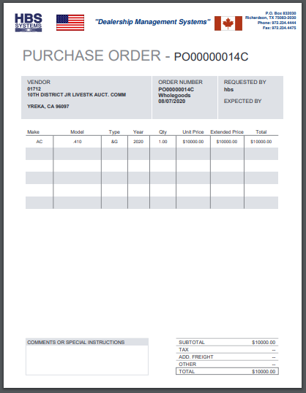



**Ordering a Unit Purchase Order:** The first action required on a Unit Purchase Order is the **Order** step, which can only be done by a user with the **Ordering Clerk** role. **NOTE:** The Order step will **always** be required on a **Unit PO** regardless of whether or not you have the “Skip Order Step” option turned on or off in the Settings screen.

To begin, the Ordering Clerk must click the **Order** Document Action. The following screen will open:

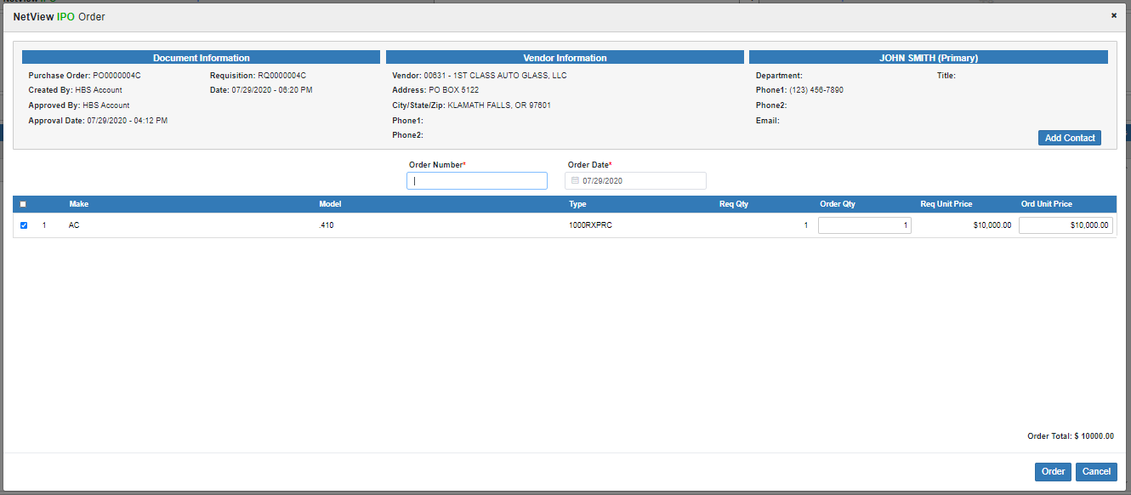

The screen will have the standard Header information as well as a running **Order Total** calculation in the bottom right-hand corner, as a preview of what will show in the **Total Ordered** field once you complete the step.

Order Number: Enter the order number you received from the vendor in this field. This information is **required** for **Unit POs.**

Order Date: Enter the order date in this field or select it from the calendar. It will default to the **current** date. This information is **required** for **Unit POs**.

Unit PO Order Grid Columns: This grid displays all the line items on the Purchase Order. Go through and input the necessary information from the vendor order to make sure the document will match the actual order.

**Mark as Ordered:** Put a check in this box to indicate that **the line item is included on the order**. If you ordered **all** the line items, you can check the **Mark All** box at the top of the column to automatically check this box for all the lines.

**WARNING!!!:** If you do **not** check this box for a line item, the line will be recorded as **Not Ordered**, preventing any user from **receiving** or **reconciling** it, as the program will assume you did not actually order the item. This could cause serious accounting issues later on if you did actually order the item.

**Line Number:** This column shows the line number.

**Make:** This column shows the item’s unit make.

**Model:** This column shows the item’s unit model.

**Type:** This column shows the item’s unit type.

**Req Qty:** This column shows the original requested quantity of the item.

**Order Qty:** This field defaults to the **Requested Quantity**. If the quantity actually ordered is **different**, enter the new quantity here, though the value must be **higher than zero** (if the quantity will be zero, you should just make the line **Not Ordered**, as explained above).

**Req Unit Price:** This column shows the original requested unit price for the item.

**Ord Unit Price:** This field defaults to the **Requested Unit Price**. If the unit price as actually ordered is **different**, enter the new unit price value here. The Order Total below the grid will then recalculate based on the new value.

Once you have gone through every line item, click the **Order** button at the bottom of the screen. The program will return to the document screen and update it to reflect the Order step’s completion:

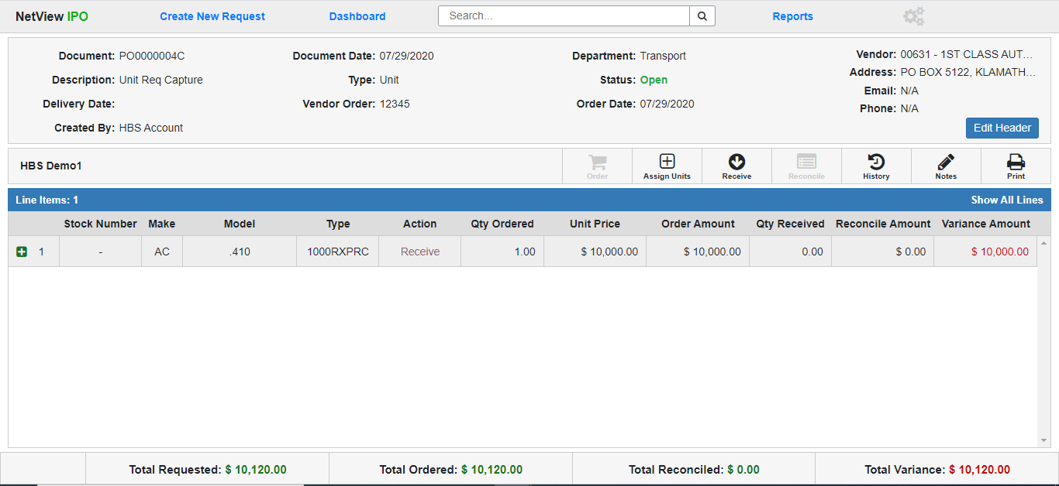

Unit Purchase Order Document (Post-Order): The Unit Purchase Order document will now show the following:

* The Vendor Order and Order Date fields in the Header will show the order number and date entered by the Ordering Clerk.
* The Order Document Action will be **disabled**, while the **Assign Units** and **Receive** actions will be **active.**
* For each line item marked as Ordered, the Qty Ordered, Unit Price, and Order Amount fields will fill with the relevant information entered for the line by the Ordering Clerk. The Variance Amount field will also display the amount on the line that has yet to be reconciled, which at this point should be the full Ordered amount (minus the Freight).
* All line items marked as Ordered will now show **Receive** in their Action field, indicating that the **Receive** step is the next action required for the lines.
* For each line item that was **Not Ordered**, the Qty Ordered, Unit Price, and Order Amount fields will show a **zero** value, and the line’s Action field will read **Completed**. The Line’s Variance Amount will fill with whatever value the Ordered Amount would have been had the line been Ordered.
* The **Total Ordered** field in the Footer will recalculate to show the total amount of all the Ordered line items (including Freight), and the **Total Variance** will update to show the total amount of the document that needs to be reconciled, which at this point should be the same as the Total Ordered amount.

**Assigning Units on a Unit Purchase Order:** Once the Unit PO has been ordered, the **Assign Units** Document Action will become active. This action **only** appears on **Unit POs**, but it can be performed by **Ordering Clerks,** **Receiving Clerks** AND **A/P Clerks**—in other words, if a user has a role that lets them act on a Purchase Order, they can perform the Assign Units action, as long as they **also** have permissions for **Unit Purchase (UP)**. This feature is what creates the system record(s) for each individual unit on the Purchase Order, a process which in non-IPO cases is conducted via UP. Using Assign Units allows the user to keep working in IPO rather than have to bounce between two different programs in order to generate the unit record(s). **NOTE:** If the user does not have UP permissions, this button will always be **disabled** when they access the document.

Once you click on **Assign Units**, the following screen will appear:

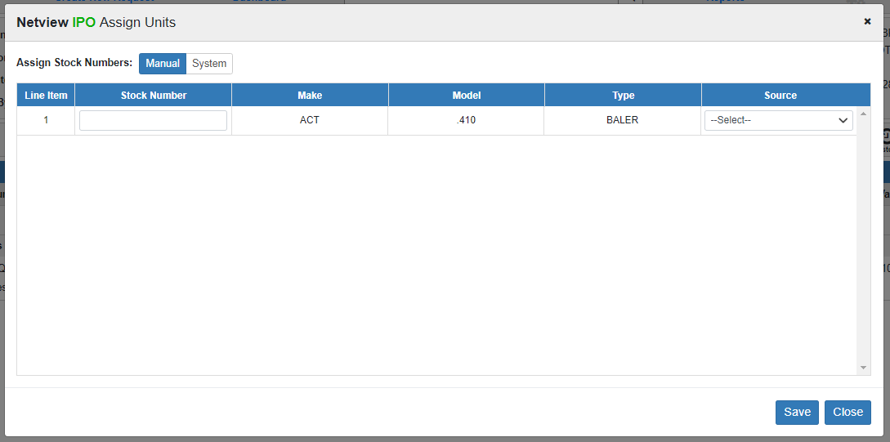

The grid that appears will show 1 entry for **every individual unit** on the Purchase Order. That means that even if the Purchase Order only has two lines, if one of those lines has 1 unit and the other has 5 units, there will be 6 entries in the grid.

For each unit, you must assign a **Stock Number** and a **Source**.

Assign Stock Numbers: You have two options for assigning stock numbers: **Manual** or **System.**

**Manual:** If you select to assign stock numbers **manually**, you must enter each stock number in yourself. The system will **validate** the entered number against existing stock numbers to prevent duplicates.

**System:** If you select to have the **system** assign stock numbers for you, the program will automatically put the word “GENERATED” in the Stock Number field for **every unit that does not have an assigned stock number**. The fields will also be **disabled**, as in the image below:

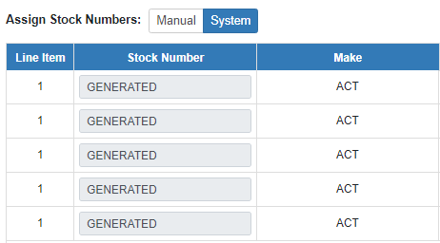

Assign Source: To assign a source to a unit, select one from the drop-down menu in the Source column. If you have multiple unit entries from the same PO line item (i.e. a **bulk** unit line), you will only have to select the source for **one** of the units—the other units’ entries will **auto-fill** with the **same** source, as in the image below:

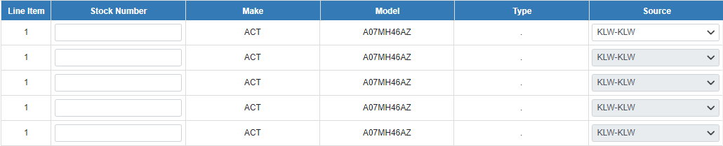

Save: Click **Save** to have the system store the information and create the unit record(s), which you will then be able to view in **Unit Inquiry (UI)**. **NOTE:** Each unit will be recorded with an **Ordered** status, which will change to **New** once the unit’s accounting is completed during the **Reconcile** step.

**NOTE:** You do **not** have to perform the Assign Units step for every line item at once, though once you save a unit with a stock number and a source it will no longer appear in this screen. However, the step needs to be done **before the Receive step**.

Once you assign the unit(s) on a line item, the stock number(s) will then appear in the **Stock Number** field:

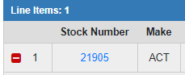

In the case of a line item with **multiple units** (i.e. a **bulk** unit line), **all** stock numbers will appear on the line. You can click on the stock number to get a quick snapshot of the unit’s current information, which will be completed once the **Receive** step is done.

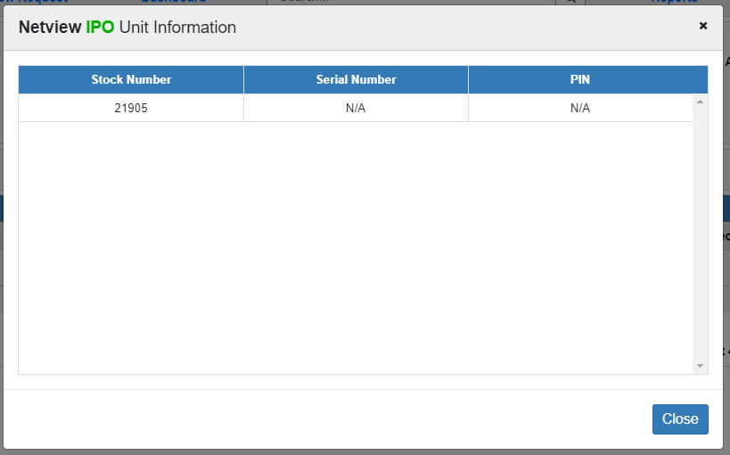

Once you have assigned stock numbers and sources to all the units on the Purchase Order, the Assign Units action will be **disabled**.



**Receiving a Unit Purchase Order:** The next step of the Unit PO comes after the **physical items** start arriving at your dealership and you complete the **Assign Units** step. Once the first delivery arrives, the **Receiving Clerk** can begin the **Receive** step, which records what line items from the order have actually been delivered. **NOTE:** The step can be performed **multiple times**, to account for the order not getting delivered all at once.

To start, click the **Receive** Document Action. The following screen with the standard Header will appear:

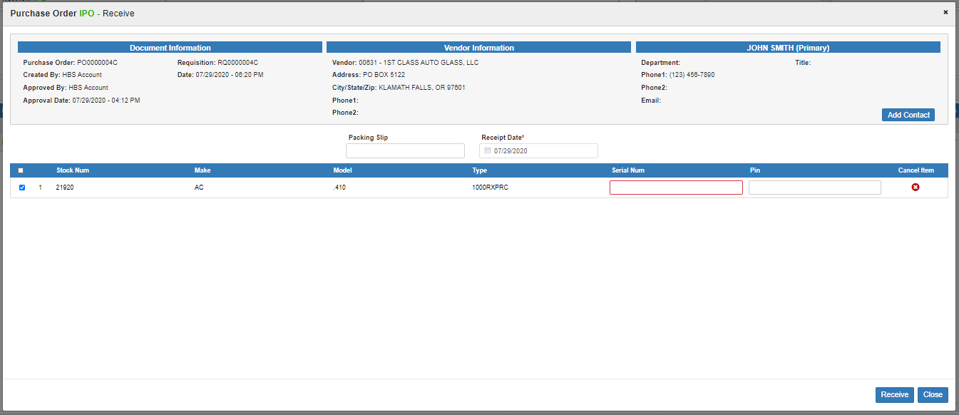

Packing Slip: Enter the packing slip number you intend to receive against.

Receipt Date: Enter the packing slip receipt date or select it from the calendar. The date will default to the **current** date. This is a **required** field.

Unit PO Receive Line Grid: The grid lists all **individual units** that have **been assigned stock numbers,** but have **not yet** been Received **or** Cancelled. If a unit does **not** have a stock number, it will not appear in this screen until it is assigned one. Once a unit isReceived, it will no longer appear in this grid.

**Select as Received:** Check the box next to each line item you want to mark as **received with this packing slip.** If the unit was **not** included on the packing slip, **do not** select it; wait until it actually arrives or until you have confirmation that it will never arrive.

**Line Number:** This column shows the line item’s number.

**Stock Number:** This column shows the unit’s assigned stock number.

**Make:** This column shows the unit make.

**Model:** This column shows the unit model.

**Type:** This column shows the unit type.

**Serial Number:** Enter the received unit’s **Serial Number** in this field. This is a **required** field. **NOTE:** This field will only be active if the unit has a **stock number.**

**Pin:** Enter the received unit’s **Pin Number** (if relevant) in this field. **NOTE:** This field will only be active if the unit has a **stock number.**

**Cancel Item:** If you learn that any units will **not** be delivered **ever**, use the red and white “x” icon in the Cancel Item column for that unit to **cancel** it.

The following window will appear:

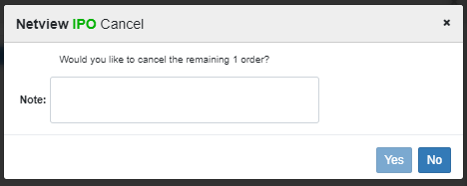

Enter an explanation for why you are cancelling the receipt in the **Note** field. This is **required** in order to cancel the unit receipt. Once you have done so, the **Yes** button will activate. Click it to cancel the unit receipt.

Once you have marked all the units from the packing slip as Received and put in their Serial & Pin numbers as needed, click **Receive** at the bottom of the screen. The program will return to the document screen and update it to reflect the changes made during the step:

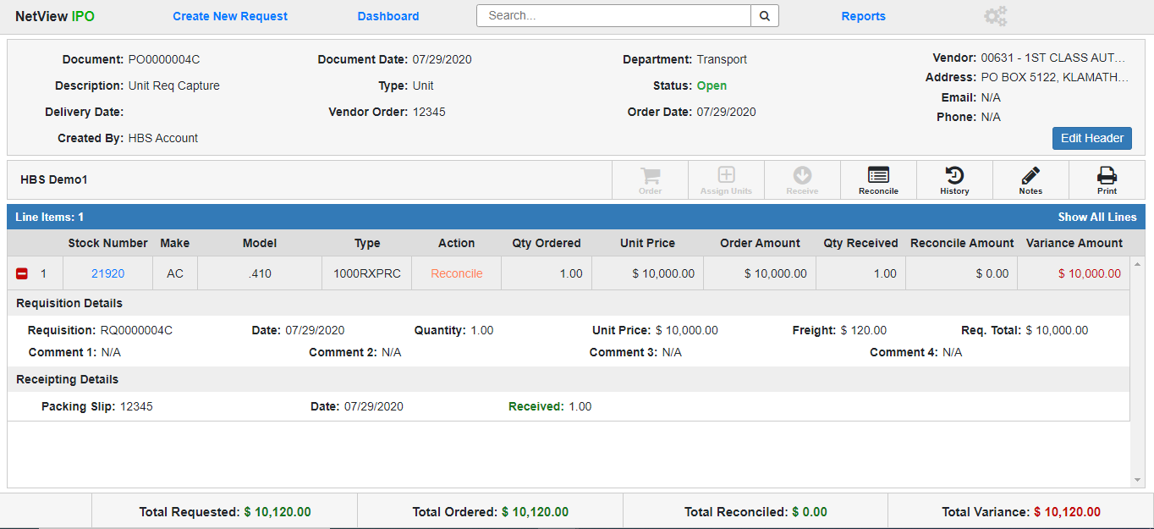

Unit Purchase Order Document (Post-Receive): The Unit Purchase Order document will now show the following:

* **Receipting Details:** When you expand the line items that have had units received, there will be a new **Receipting Details** section (see image above), which will hold a line for every Receive instance performed on the line (if done more than once). Each line will show the following information about the Receipt:
  + **Packing Slip Number**
  + **Receipt Date**
  + **Quantity Received** (will show in **green**) or **Quantity Cancelled** (will show in **red**)
* Once **all** the units on a line item are received, the line’s **Action** column will change to read **“Reconcile,”** indicating that the next step is to reconcile the line item’s accounting.
* Once at least **one** line item has been completely received, the **Reconcile** Document Action will **activate**, allowing you to start reconciling the received line if you are ready to do so (see the next section for more information).
* Once **all** the line items are received, the Receive Document Action will **deactivate.**

**Reconcile a Unit Purchase Order:** **Reconcile** is the final step needed to complete a Purchase Order, and must be performed by the **A/P Clerk**. It requires that the A/P Clerk have the **vendor invoices** for the delivered line items so they can record the invoice information in the system and perform the unit accounting. Once a line item has been **received** and the A/P Clerk has the invoice for that line item, begin by click the **Reconcile** button. The following screen will appear:

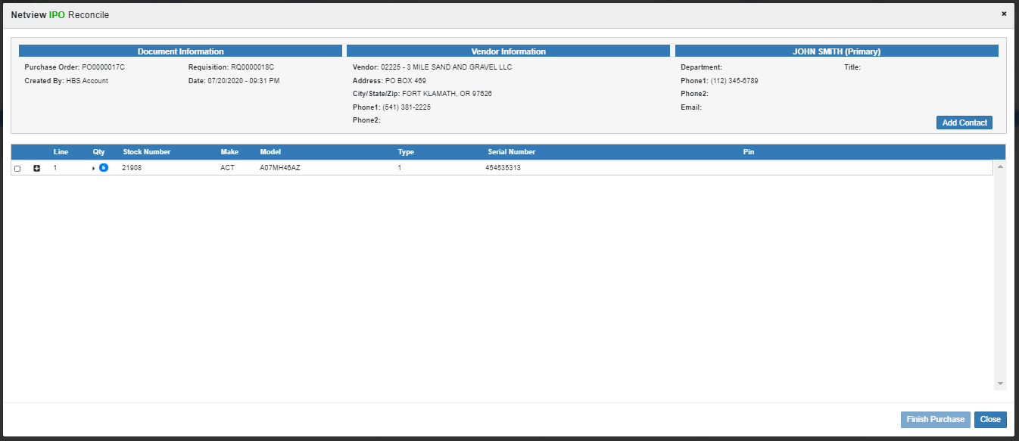

Unit PO Reconcile Grid—Main Columns: The grid will list all line items that have been **received** and thus ready to be reconciled to an invoice. The main line of the grid will be **display only**.

**Select for Reconcile:** Check this box to select the line item to be reconciled. This will automatically expand the line to show its **accounting fields** (see that section below for more details). **NOTE:** You **cannot** finish the line’s accounting if you do not check this box, though you can work on it.

**Line:** This column shows the line number.

**Qty:** This column shows the quantity of units on the line. If the line has more than 1 unit, click the arrow icon next to the number to show all the units’ information (see image below); otherwise, the remainder of the line entry will only show the details for the first unit on the line item.

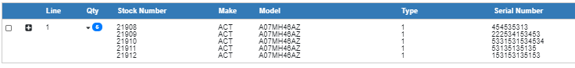

**Stock Number:** This column will show the stock number(s) included on the line item.

**Make:** This column will show the unit make.

**Model:** This column will show the unit model.

**Type:** This column will show the unit type.

**Serial Number:** This column will show the serial number(s) for the line item unit(s).

**Pin:** This column will show the pin number(s) for the line item unit(s), if recorded.

Unit PO Line Reconcile Accounting: Expand the line using the “**+**” icon to view and work on the line item’s accounting. **NOTE:** The line will automatically expand to show these fields if you have selected it by checking its “Selected for Reconcile” box.

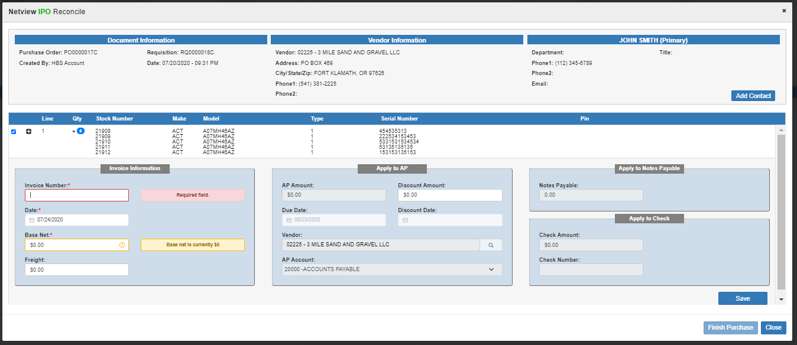

**Invoice Information:** Fill in this section with the **invoice** details that apply to the line item.

* **Invoice Number:** Record the invoice number in this field. This information is **required**.
* **Date:** Enter the invoice date in this field or use the calendar to select it. This information is **required**. **NOTE:** The date must be in an **open** accounting month and not exceed your system's set future date limit. The program will not accept it otherwise.
* **Base Net:** Enter the invoice’s base net amount for this line item, which will be **evenly split** between the line’s units if it holds more than one. This information is **required**. Once you enter the value, the fields in the three “Apply” sections will activate, allowing you to enter how the invoice will be/was paid. The **Notes Payable** field in particular will automatically fill with the Base Net amount.
* **Freight:** Enter any Freight amount listed on the invoice here, which will be **evenly split** between the line’s units if it holds more than one.

**Apply to AP:** If you intend to pay **any** part of the line item using **Accounts Payable**, fill in this section.

* **AP Amount:** Enter the amount of the Base Net and/or Freight that you intend to pay with A/P in this field. This will activate the remaining fields in this section (minus the Discount Date).
* **Discount Amount:** Enter any discount amount for the invoice in this field if paying the invoice with A/P.
* **Due Date:** Enter the invoice’s due date in this field or select it from the calendar. The field will provide a default date determined either by the **vendor’s** settings in VIM, or to **30 days from the current date** if the vendor has no defaults already set. Additionally, if you change the Invoice Date from the current date, this field will recalculate to 30 days from the new Invoice Date. This field is **required** if you are paying any part of the invoice with A/P.
* **Discount Date:** This field will only activate if you enter a Discount Amount. Enter the discount date in this field or select it from the calendar.
* **Vendor:** This field will automatically fill with the vendor listed on the Purchase Order, but must be **changed** if the order was actually placed at a different vendor. Enter the new vendor’s number or use the Vendor Search to look it up. This field is **required** if you are paying any part of the invoice with A/P.
* **AP Account:** This field holds the A/P account for the payment. It defaults to either the **20000** account or, if you have multiple A/P accounts, whatever account you have set as your default. If you have multiple accounts, you can use the dropdown to change the payment account. This field is **required** if you are paying any part of the invoice with A/P.

**Apply to Notes Payable:** The **Notes Payable** field will automatically fill with the Base Net amount once you enter it. If you choose to pay any part of the Base Net using either A/P or a check, it will automatically subtract those amounts from its displayed value. Adjust the value in this field so it match how much of the invoice you want to pay using Notes Payable.

**Apply to Check:** If you want to pay any part of the line item off with a **check**, enter that information in these fields.

* **Check Amount:** Enter the amount you want to pay using a check in this field.
* **Check Number:** Enter the check number in this field.

**Save:** At any time while reconciling the line item, you can click **Save** to store the current information you entered. This allows you to stop and start work on the line as needed. You can even close the Reconcile screen and return to pick up exactly where you left off.

**Close:** Click this button to close the screen if needed. Any line item accounting **not saved** will be **deleted** if you do this, so make sure to save your work before you leave the screen.

Finish Purchase: Once a selected line item is in **balance** (the Base Net is fully distributed among the payment fields), its grid entry will turn **green** (this will not occur if the line is **not selected,** even if its accounting is in balance) and the **Finish Purchase** button will activate. Click it to reconcile the line item and save the unit accounting. The screen will close and return you to the main document screen. **NOTE:** Any lines that are either not selected, or selected but not colored green, will **not be affected** by clicking “Finish Purchase.”

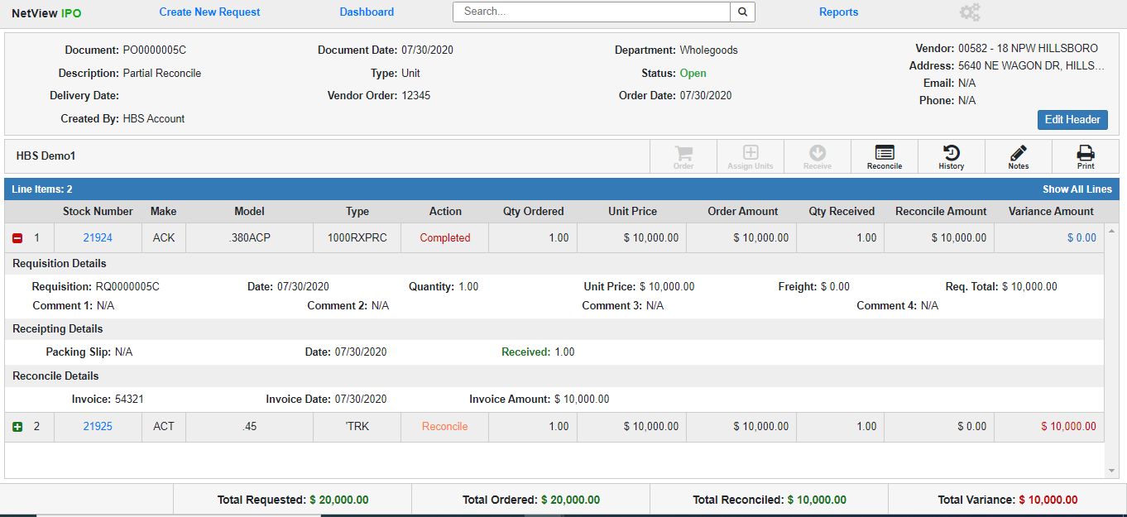

The following changes will have occurred:

* **Reconcile Details:** When you expand the Reconciled line items, there will be a new **Reconcile Details** section (see image above), which will show the following information about the invoice the line was reconciled against:
  + **Invoice Number**
  + **Invoice Date**
  + **Invoice Amount** (not including Freight)
* The Reconciled line item(s) will now show **Completed** in their Action column, showing that no further action can be taken on those items.
* The **Reconcile Amount** field for each line item will fill with the Invoice Amount, and the **Variance Amount** will calculate based on the difference between it and the **Ordered Amount**.
* The **Total Reconciled** field in the Footer will recalculate to include the Reconciled Amounts of the Completed line items, and the Total Variance will recalculate based on the difference between it and the **Total Ordered** field. **NOTE:** Reconciled **Freight** amounts will be included in this calculation.
* Checking the **unit records** of the reconciled units in **Unit Inquiry (UI)** will show that their statuses have changed from **Ordered** to **New**, and all their accounting has been filled in.
* If any line items have **not** been reconciled yet, the **Reconcile** Document Action will remain active, and the Purchase Order will remain open.

**Closing a Unit Purchase Order:** Once **all** line items on the Purchase Order have been **reconciled**, the Purchase Order will **automatically** change its status to **Closed** and become a **historical** document.

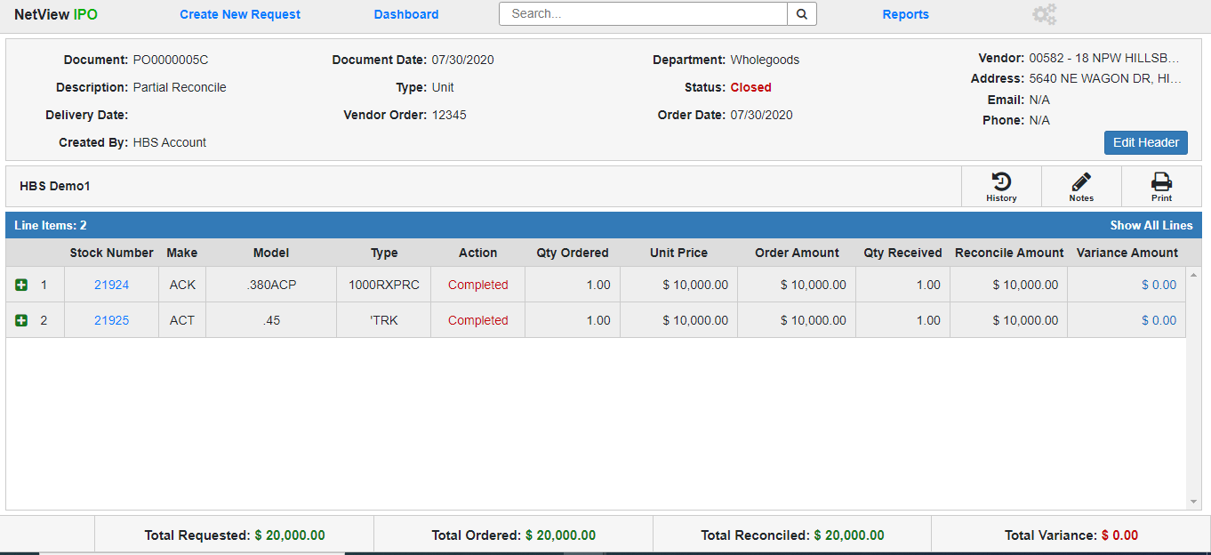

The following changes have occurred:

* All the line items now have a status of **Completed**.
* All Document Actions will disappear from the Toolbar except **Notes, History,** and **Print**, which can still be done by any user who can access the document.